**TASK 1- Academic Management System ( using SQL)**

3.

1. Retrieving Student Information.

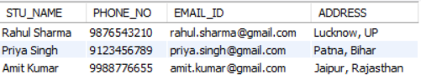

1. Retrieving list of courses in which a specific student is enrolled

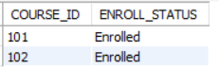

1. Retrieving Course Information

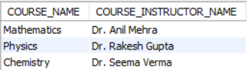

1. Retrieving Course Information for a specific course



1. Retrieving Course Information for multiple course

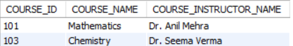

4.

A. Retrieving the number of students enrolled in each course

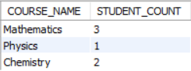

B. Retrieving the list of students enrolled in a specific course

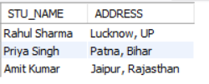

C. Retrieving the count of enrolled students for each instructor.

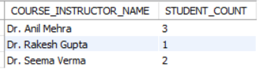

D. Retrieving the list of students who are enrolled in multiple courses

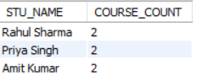

E . Retrieving the courses that have the highest number of enrolled students(arranging from highest to lowest)

